

CSF 3133: Antara Muka Laman Web

Lab Report 5
Name: CHONG YU
Matric No.: S76136
Group: K4
Program:
Computer Science (Software Engineering)

Activity 5.3
Code:
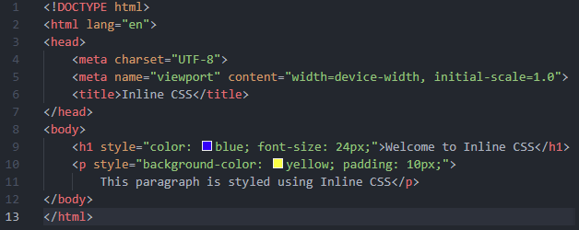
Output:



Activity 5.4
Code:
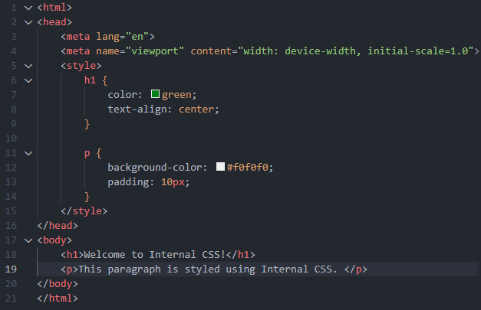
Output:
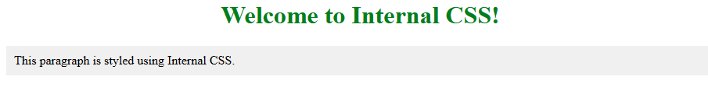

Activity 5.5

Code:
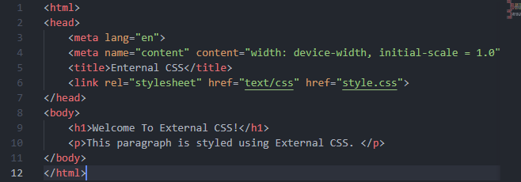
Output:
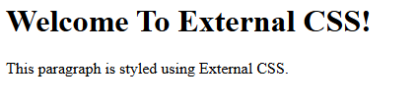
The output are the same due to the different name of css file when creating and inside the html code.

Activity 5.6
Code：
Original Font:
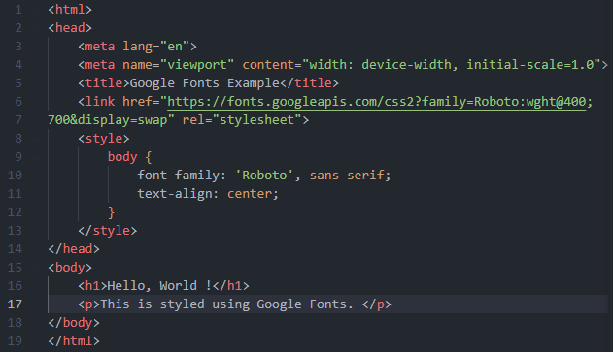
Changing the font:
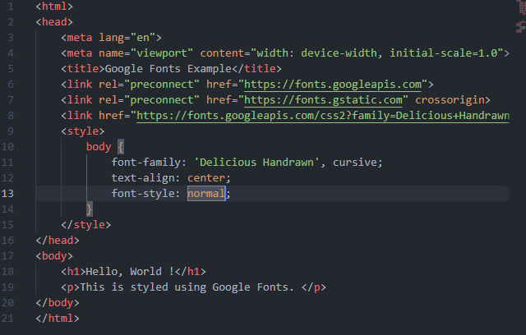
Output:
Font Roboto
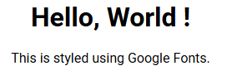
Delicious Handrawn:
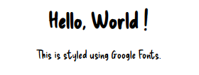

Activity 5.7
Code:
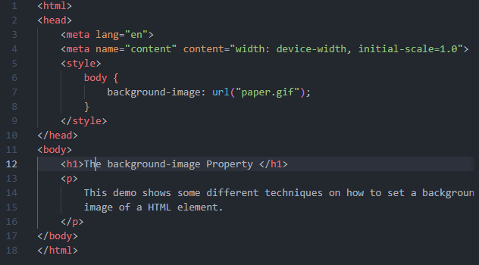
Output:
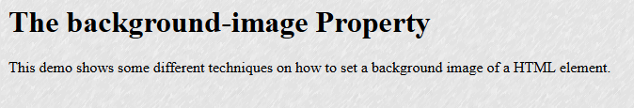
Changing to multiple image
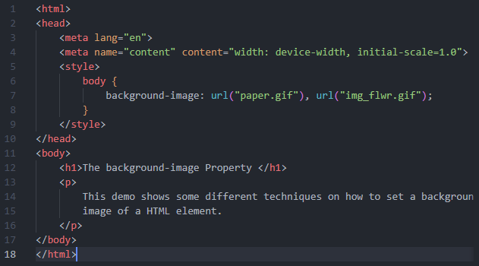
The output still the same.
But if change the sequence of the image:
Code:
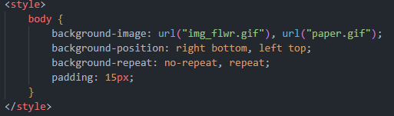

Output:
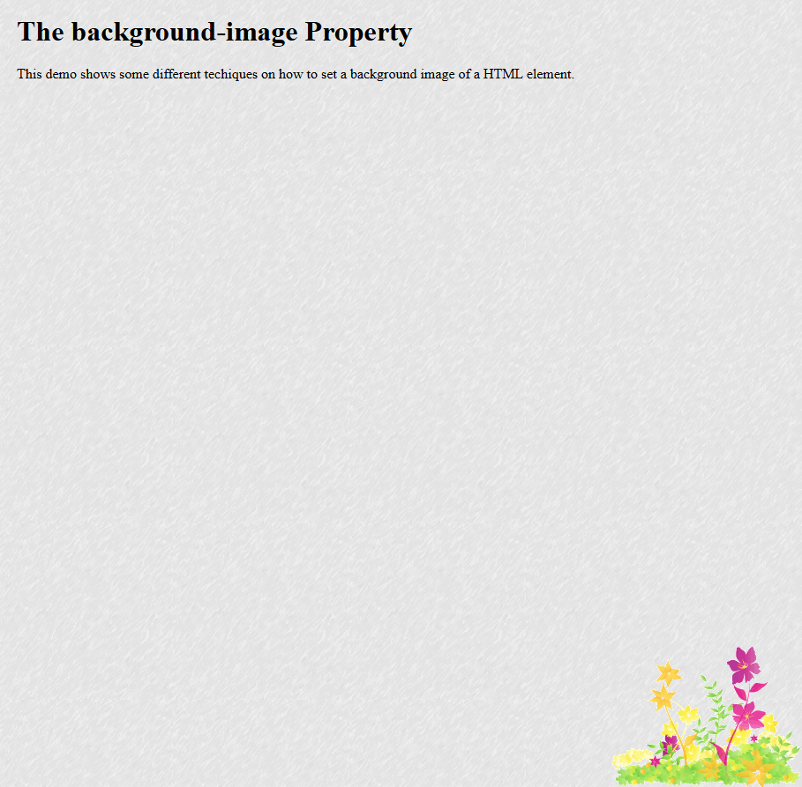

Change the content into longer content:
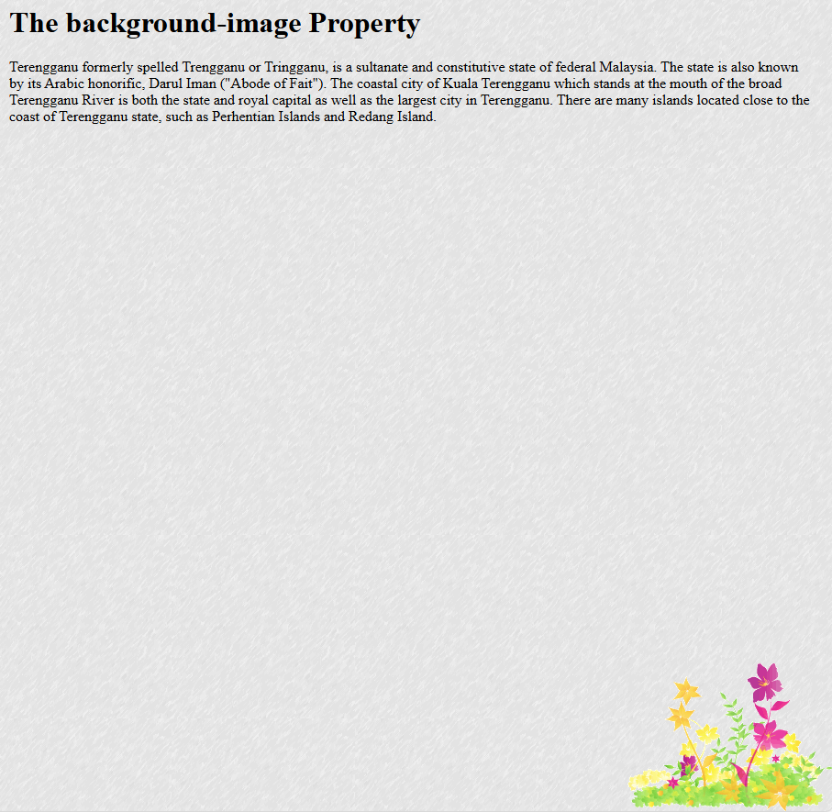

Explore the different background properties:
Code:
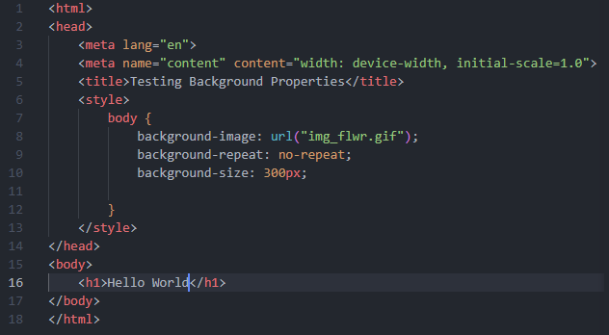
Output:


Activity 5.8
Code:
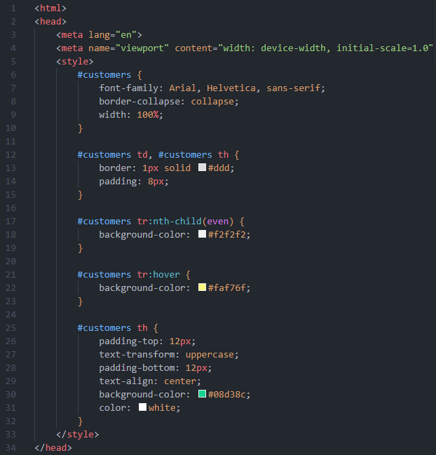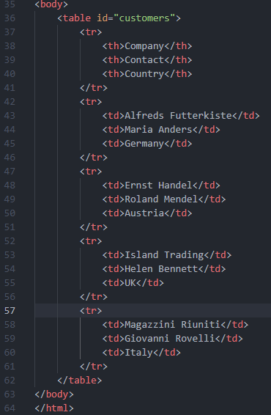
Output:
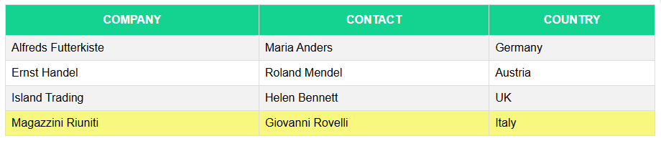

Activity 5.9
Before adding css:
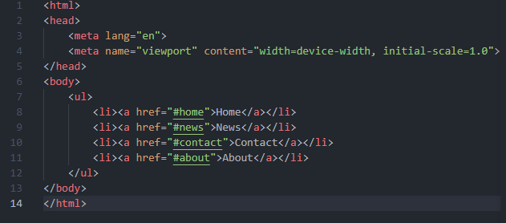Before adding css:

Remove the bullets point from the list
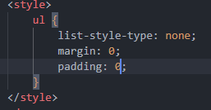


Change the style of navigation menu:
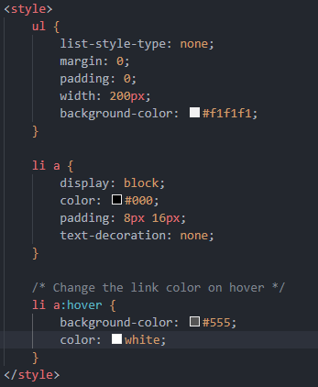
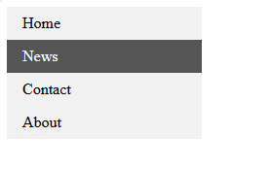

Make navigation bar horizontal:
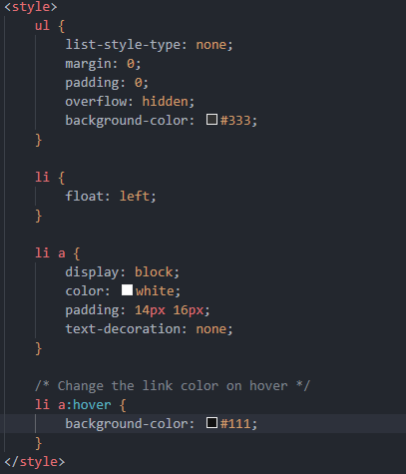


Lab exercise:
Output:
